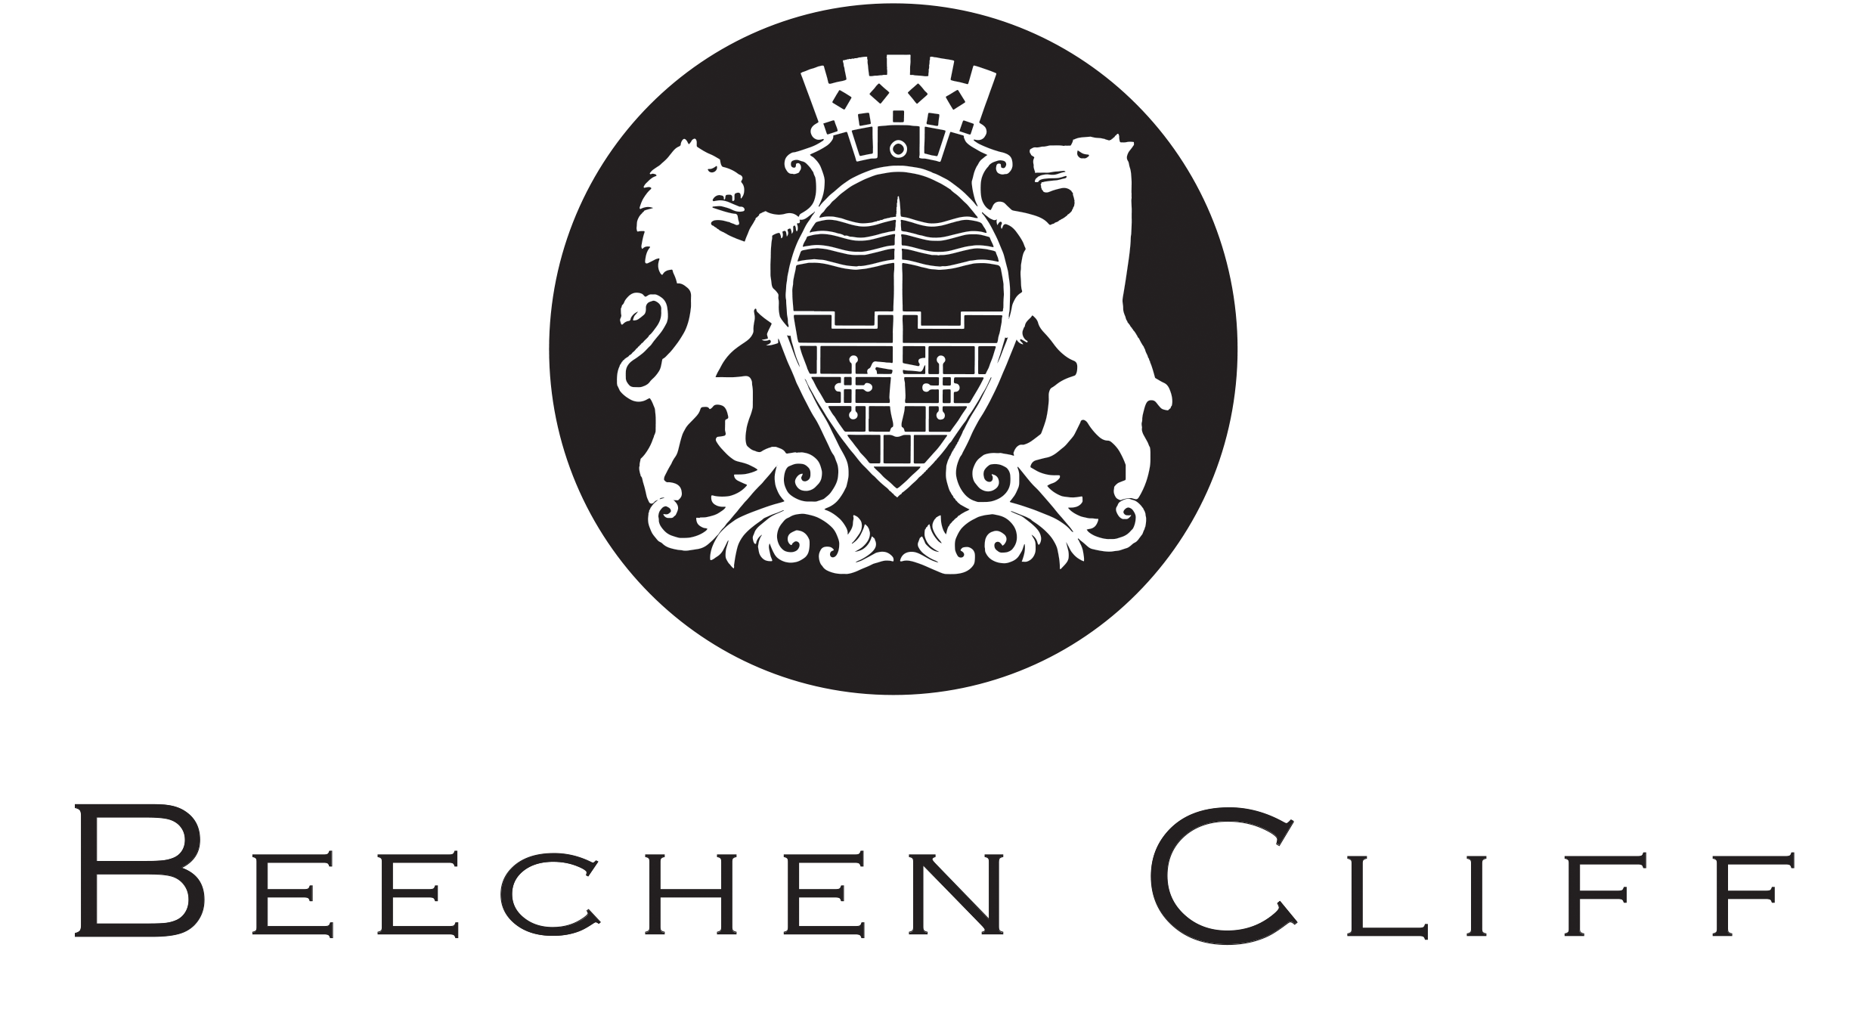

CAREERS EDUCATION, INFORMATION, ADVICE AND GUIDANCE POLICY

Author: Mr Ernst Bakker
Date of Review: November 2020
Approved by:
Date of Approval:
Next Review: June 2021

Future Horizons – CEIAG at Beechen Cliff
Introduction

The Education Act 2011 transferred responsibility for careers guidance from local authorities to schools and there is now a duty for schools to secure independent and impartial careers guidance for all year 8-13 pupils. This policy has been adopted as a mark of the importance that Beechen Cliff School places on Career education and guidance that prepares students for challenges in their future lives.

The Beechen Cliff School CEIAG policy and Future Horizons programme follows the Department for Education document ‘Careers guidance and access for education and training providers -
Statutory guidance for governing bodies, school leaders and school staff’ (October 2018)

It is recognised that an effective CEIAG programme can help inspire and motivate young people to achieve their full potential. It can contribute to achievement and inclusion by raising aspirations, challenging stereotypes and enabling young people to make realistic and informed choices about their futures through consideration of a broad and ambitious range of education and employment options.

Aims and Objectives
- To facilitate learners in developing and broadening their career aspirations.
- To provide learners with a broad range of knowledge and information to enable them to make informed decisions about their futures.
- To expose learners to a range of careers, employment and educational experiences, allowing them to select suitable pathways into further education, training, and employment
- To ensure all learners are aware of a diverse range of opportunities that are on offer.
- To ensure all learners know where to find and how to access information and guidance.
- To enable learners to evaluate and identify strengths and weaknesses, and areas they need to develop to prepare them for their next steps.
- To develop learners employability and ability to promote themselves.
- To promote equality of opportunity and challenge stereotypes

At the heart of our Careers Education, Information, Advice and Guidance programme is the Careers guidance and access for education and training providers October 2018 and the Gatsby Benchmarks. In 2014 the Gatsby Charitable Foundation published a report by Professor Sir John Holman titled “Good Career Guidance.” The report identified eight benchmarks that are at the core of good careers guidance and form the Careers Strategy, with the expectation that all schools are working towards these benchmarks and meeting them by 2020.

Organisation

Mr Andrew Davies – Headmaster
Mr Martin Birchall - CEIAG Governor
Mr James Oldham – CEIAG Senior Leader
Miss Kim Mather - UCAS, Sixth Form Future Horizons & EPQ Coordinator
Mr Ernst Bakker – Careers Lead (Lower School)
Mrs Yvonne Burcham – WEX Co-ordinator and Careers Admin
Mrs Emma Pascoe – Independent Careers Advisor

Delivery and Content

We believe that careers education at Beechen Cliff is not a standalone subject, and it is in fact contributed to by all of our teaching faculties and the staff within them. Similarly, careers activities outside of subject teaching compliments the learning in subject faculties. Beechen Cliff offers a wide range of opportunities and activities across the key stages for careers related education. In order to best meet the needs of our pupils, these activities are tailored for individuals and specific groups at different stages of their school careers. This enables them to make informed decisions about their next steps in education and prepares them for working life.

Specific careers activities are delivered in collapsed timetable sessions, and they are delivered by both teachers, tutors and visiting professionals. The content of these activities are delivered at times which most suit our pupil’s needs at the right stages of their journey through the school and beyond. Some activities for certain year groups are also delivered through PSHE lessons in timetabled lesson times. Assemblies for whole year groups and selected groups of pupils take place across the academic year, and we regularly welcome external organisations, businesses and academic institutes to deliver these.

Future Horizons – Core Programme in brief

Year 7

Introductory assembly – ‘What is Careers Education?’
My Strengths & Skills - Skills & Personal Qualities

Year 8

Job categories
Self-reflection and selling yourself
What Influences Me - Influences & Decisions
What Influences Me - Shaping the Future
Year 8 Enterprise Day, Royal High School

Year 9

Stereotyping - Impact on Planning & Subject Choices
Knowing my KS4 Options - Informed Choices & Qualifications
Knowing my KS4 Options (Parents Information Evening)
Who can help me? – Where to find information and guidance (Year Group Assembly)

Year 10

KS4 Future Horizons introduction – Presentation at GCSE Parent Information Evening
Post 16 Options Assembly – ‘What are my options after Year 11?’
Post 16 Options – Researching Options
Aspiration in Practice – Activity
Employability – Activity
Competition for Jobs – Activity
Interview Skills - Activity
Year 10 Parents Oxbridge Information Evening (JCO)
BaNES & Bath College Apprenticeships Fair
MNSP Careers Fair – Writhlington School

Year 10 Work Experience (WEX)
Work Experience Launch – Year group assembly
WEX – Applying for placements – Group session
Health and Safety Briefing – Group session
Work Experience Week

Year 11

Post 16 Options Assembly – ‘What are my options after Year 11?’
Headmasters’ Interview – Plans and Aspirations
Choosing A-Levels – Year 11 Assembly
Applying to the Sixth Form – Year 11 Assembly
Post 16 Entry Requirements – Tutor Activity
Writing a CV - Skills & Personal Qualities
Writing a CV - The Personal Statement
BaNES & Bath College Apprenticeships Fair
MNSP Careers Fair – Writhlington School

Year 12
Future Horizons termly newsletter
Graduate Careers Showcase
Careers Insights Series
‘Why Go To Uni?’ Information Morning
UCAS Fair at UWE
Future Horizons careers research day
Oxbridge programme
BaNES Oxbridge conference
Work Experience assembly
MedSoc

Year 13
Future Horizons termly newsletter
Careers Insights Series
Independent careers appointments from UWE
Personal statement drop-in sessions
UCAS application assembly
Mock Interview Morning
Leaver Destination Plans
Interview practice
Student Finance assembly and information evening
Careers and life skills workshops by Bath Building Society

Student Needs and Entitlement

All students are entitled to CEIAG which meets the professional standards of practice, which is both impartial and person-centred. The Future Horizons programme is planned and implemented to consider the needs of all learners. Activities are differentiated or made specifically available for certain groups of students where appropriate, and consider the different stages of career learning and pathways. Partnership is encouraged between students, parents and teachers in the delivery and journey through careers education.

Access

We strive to ensure that all pupils and students are made aware of the broadest range of options for further education, training and employment at all stages. This is not limited to just those on offer within our school, and our pupils and students have access to external providers to ensure that they have a full picture of potential opportunities and pathways. External providers may have access to pupils and students to inform them of opportunities. All enquiries from external providers should be sent to the Careers Lead in the first instance.

Resources

Funding is allocated in the whole school annual budget planning, and needs and priorities of the CEIAG programme is taken into account.

Tracking Data

A central database is kept of all careers, education, information, advice, guidance and work related interactions and activities. Each individual pupil has a profile kept on the database which is updated regularly to keep account of information received and involvement in CEIAG activities.

Post 16 destination data is gathered with communication with the LEA and other educational establishments.

Evaluation and Review

An annual review of the progress and impact that the Beechen Cliff CEIAG Programme is making will take place at the end of each academic year. The Careers and Enterprise Company ‘Compass Evaluation Tool’ will be used to record and track progress. Review and evaluation of specific activities will be sought from those delivering and taking part in the activities, as well as parent feedback.

Beechen Cliff School is a member of the West of England Combined Authority Careers Hub, and is advised and supported by an enterprise co-ordinator from the Hub. Reviews of progress against the Gatsby Benchmarks is undertaken by the Careers Lead and Enterprise Co-ordinator at three points throughout the academic year.

Students and Parents are welcome to give feedback on all CEIAG activities and provision, and contact details and forms are available on the CEIAG pages of the school website, or by contacting the school office directly.

Related Documents

Department for Education – Careers guidance and access for education and training providers - Statutory guidance for governing bodies, school leaders and school staff, October 2018
The Gatsby Charitable Foundation – The Gatsby Benchmarks
Midsomer Norton Schools Partnership – Careers Education, Information, Advice and
Guidance Policy
Beechen Cliff School – PSHE Policy

Definitions

CEIAG – Careers Education, Information, Advice and Guidance refers to a coherent programme of careers education supported by personalised information, advice and guidance tailored to the individual needs of the pupil. Together they equip pupils with the knowledge and skills that they need to make realistic and informed choices about their own progression through learning and work.

Careers Education refers to careers teaching and learning which helps pupils to develop the knowledge, confidence, attitudes, aspirations and skills that they need to make well informed choices and plans that enable them to progress smoothly into further learning and work.

Careers Information refers to the range of career and course related material that can be readily accessed by pupils.

Careers Advice and Guidance refers to targeted interventions to meet the individual needs of the pupil. This includes face-to-face interviews, group work, and the use of carefully selected on-line resources. This is delivered by school staff supplemented by a range of independent sources including external careers advisers, employers, educational establishments, alumni and other organisations.

Appendix 1

The Gatsby Benchmarks

1. A stable careers programme

Every school and college should have an embedded programme of career education and guidance that is known and understood by students, parents, teachers, governors and employers.

- Every school should have a stable, structured careers programme that has the explicit backing of the senior management team, and has an identified and appropriately trained person responsible for it.
• The careers programme should be published on the school’s website in a way that enables
pupils, parents, teachers and employers to access and understand it.
• The programme should be regularly evaluated with feedback from pupils, parents, teachers
and employers as part of the evaluation process.

2. Learning from career and labour market information

Every student, and their parents, should have access to good quality information about future study options and labour market opportunities. They will need the support of an informed adviser to make best use of available information.

- By the age of 14, all pupils should have accessed and used information about career paths and the labour market to inform their own decisions on study options.
• Parents should be encouraged to access and use information about labour markets and
future study options to inform their support to their children.

3. Addressing the needs of each student

Students have different career guidance needs at different stages. Opportunities for advice and support need to be tailored to the needs of each student. A school’s careers programme should embed equality and diversity considerations throughout.

- A School’s careers programme should actively seek to challenge stereotypical thinking and raise aspirations.
• Schools should keep systematic records of the individual advice given to each pupil, and subsequent agreed decisions.
• All pupils should have access to these records to support their career development.
• Schools should collect and maintain accurate data for each pupil on their education, training
or employment destinations for at least three years after they leave the school.

4. Linking curriculum learning to careers

All teachers should link curriculum learning with careers. STEM subject teachers should highlight the relevance of STEM subjects for a wide range of future career paths.

- By the age of 14, every pupil should have had the opportunity to learn how the different STEM subjects help people to gain entry to, and be more effective workers within, a wide range of careers.

5. Encounters with employers and employees

Every student should have multiple opportunities to learn from employers about work, employment and the skills that are valued in the workplace. This can be through a range of enrichment activities including visiting speakers, mentoring and enterprise schemes.

- Every year, from the age of 11, pupils should participate in at least one meaningful encounter* with an employer.

*A ‘meaningful encounter’ is one in which the student has an opportunity to learn about what work is like or what it takes to be successful in the workplace.

6. Experiences of workplaces

Every student should have first-hand experiences of the workplace through work visits, work shadowing and/or work experience to help their exploration of career opportunities, and expand their networks.

- By the age of 16, every pupil should have had at least one experience of a workplace, additional to any part-time jobs they may have.
• By the age of 18, every pupil should have had one further such experience, additional to any part-time jobs they may have.

7. Encounters with further and higher education

All students should understand the full range of learning opportunities that are available to them. This includes both academic and vocational routes and learning in schools, colleges, universities and in the workplace.

- By the age of 16, every pupil should have had a meaningful encounter* with providers of the full range of learning opportunities, including Sixth Forms, colleges, universities and apprenticeship providers. This should include the opportunity to meet both staff and pupils.
• By the age of 18, all pupils who are considering applying for university should have had at least two visits to universities to meet staff and pupils.
*A ‘meaningful encounter’ is one in which the student has an opportunity to explore what it is like to learn in that environment.

8. Personal guidance

Every student should have opportunities for guidance interviews with a career adviser, who could be internal (a member of school staff) or external, provided they are trained to an appropriate level. These should be available whenever significant study or career choices are being made.

- Every pupil should have at least one such interview by the age of 16, and the opportunity for a further interview by the age of 18.

